Chapter 6, Solution 11.

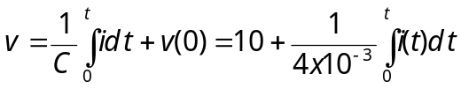
For 0<t <2, i(t)=15mA, V(t)= 10+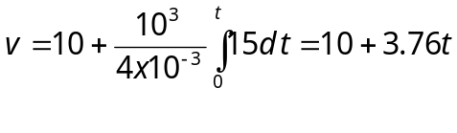
v(2) = 10+7.5 =17.5

For 2 < t <4, i(t) = –10 mA
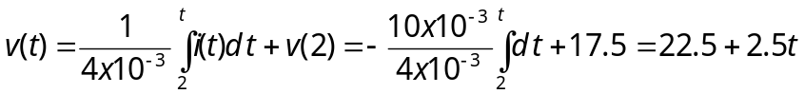

v(4)=22.5-2.5x4 =12.5

For 4<t<6, i(t) = 0, 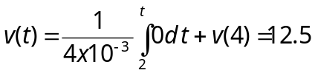

For 6<t<8, i(t) = 10 mA

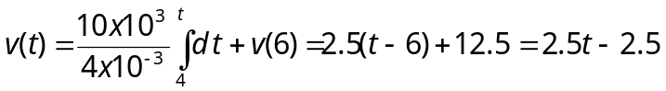

Hence,
v(t) = 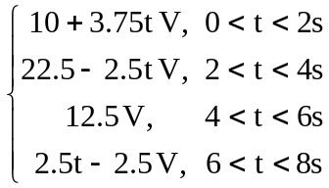
which is sketched below.
v(t)

20

15

10

5
t (s)
0 2 4 6 8

